**1.Write a Query that will return the Customer’s name, state, and order date if they were in the month of February and in the states of Illinois and Michigan.**

Select cust_name

,order_date

,cust_state

From Orders o, customers c

Where DATEPART(MONTH,order_date) = 2 and

o.cust_id=c.cust_id and

cust_state in ('MI','IL')

Results:

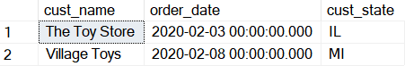

**2.Write a SQL Statement that will return the Sales Rep and their total amount of sales by millions.**

select (CONCAT( RepFirstName,' ', RepLastName)) AS Sales_Rep

,Round(Sum((SalesTotal)/1000000),1) as Total_by_Mil

From examples.dbo.SalesTotals ST ,examples.dbo.SalesReps SR

Where St.RepID=SR.RepID

Group by (CONCAT( RepFirstName,' ', RepLastName))

Having Round(Sum((SalesTotal)/1000000),1) > 1

Order by Total_by_Mil DESC;

Results:

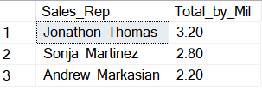

**3.Write a SQL statement that shows: the customer’s name, name of the product ordered, the total order price of each order, and finally who the vendor was for each product.**

Select c.cust_id

,cust_name

,prod_name

,prod_price

,quantity

,prod_price* quantity as Total_Order_Price

,vend_name

From TestDB.dbo.OrderItems oi

Join Orders O on oi.order_num=o.order_num

Join Customers C on o.cust_id=c.cust_id

Join Products p on oi.prod_id=p.prod_id

Join Vendors v on p.vend_id=v.vend_id

Results:

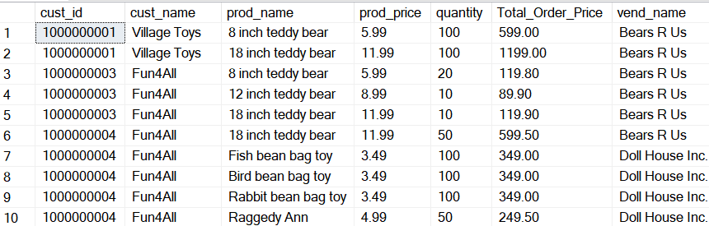

**4.Using the last query write a query that categorizes the size of e each order. If the total order price < $500 then it’s a small order, If the total order price is between $500 and $1,000 then medium, anything greater than $1,000 is a larger order. Return the count of each order rating from greatest to least.**

Select ISNull(Order_Rating,'Total') as Order_Rating

, Count (Order_Rating) as Total_count

From

(

Select c.cust_id

,cust_name

,prod_name

,prod_price

,quantity

,prod_price* quantity as Total_Order_Price

,vend_name

,Case

When prod_price* quantity <500 Then 'Small Order'

When prod_price* quantity <1000 Then 'Medium Order'

Else 'Large Order'

End Order_Rating

From TestDB.dbo.OrderItems oi

Join Orders O on oi.order_num=o.order_num

Join Customers C on o.cust_id=c.cust_id

Join Products p on oi.prod_id=p.prod_id

Join Vendors v on p.vend_id=v.vend_id

)as rating

group by Rollup(order_rating)

Order by Total_count DESC;

Results:

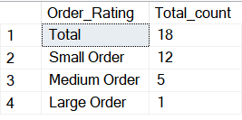

**5.Write a query that returns the : Agent’s CODE, Name , Workplace, total number of orders, the average order amount, total order amount per agent and the overall total Order amount who work in the United States.**

With agents as

(

SELECT

Distinct a.agent_CODE

,A.AGENT_NAME

,CONCAT(RTRIM(WORKING_AREA),', ',COUNTRY) as Work_Area

,(Count(*) Over ( Partition by o.Agent_CODE)) Total_Num_of_Orders

,(CAST(AVG(ORD_AMOUNT) over (PArtition by A.Agent_CODe ) AS money)) AVG_ORD_Amount

,CAST(Sum(Ord_Amount) Over ( Partition by A.Agent_CODE )AS money) ORD_Amount_Total_per_Agent

,CAST(Sum (ord_amount) Over () AS money) Total_Amount

FROM [Practice].[dbo].[AGENTS] a

Join ORDERS O on a.AGENT_CODE=o.AGENT_CODE

where Country IN ('USA')

)

Select * From agents;

Results:

